JOINT GLOBAL STATEMENT
FROM
THE PROFESSIONAL BODIES FOR
COACHING, COACHING PSYCHOLOGY, MENTORING & SUPERVISION

Dated 13/10/2020 v2.0

Humankind faces one of its biggest challenges in the current climate and biodiversity crisis. This challenge has been building for decades; many experts concur on the understanding that we have at most a ten-year window of opportunity to address the changes needed to slow down and stabilise the worst-case scenarios of runaway climate change before an irreversible tipping point is reached.

We write this statement in the midst of the coronavirus pandemic. It is noteworthy how swiftly people have changed their behaviours in response to the pandemic, how they have come together to collaborate, share resources and do what needs to be done in the face of danger. This response provides many clues and possibilities for useful actions as we face the ongoing greater threats to our climate and ecology which equally provides us with a landscape of learning.

The facts of the ecological crisis are compelling and can be seen in reports by organizations such as the IPCC. Hundreds of organisations, including governments, have acknowledged and declared a climate emergency. The WHO have estimated that between 2030 and 2050, climate change is expected to cause approximately 250,000 additional deaths per year, from malnutrition, malaria, diarrhoea and heat stress alone. For some climate change represents a concern for future generations. For others crop failures, floods, economic breakdown and stark choices around survival are a current reality. The crisis is highly complex with many interlocking aspects, ranging from protection of natural environments to economic and social issues to mental health concerns.

The interconnectedness of all species and earth systems means this situation can only be tackled through collective action and collaboration at local and global levels. Thankfully, collaboration and connection are hard wired into our DNA and offer us the opportunity to come to this challenge with hope and love, rather than with fear and anxiety.

Coaching, mentoring, coaching psychology and supervision are concerned with developing the potential of human beings, of raising awareness to enable people to take responsibility for their actions and ownership for their contribution. We have a significant role to play in fostering new ways of being in service to a healthy human society and a healthy planet.

As professional bodies who are dedicated wholly or in part to the role of coaching, coaching psychology, mentoring and supervision, to develop individuals, teams, organisations, and to create social value, we have committed to work together to play our part in addressing the climate emergency.

We consider our role in four dimensions:
- As individual human beings
- As individual coaches, coaching psychologists, mentors and supervisors
- As individual professional bodies
- As a collective of professional bodies.

It is in this fourth dimension, as a collective of professional bodies, that we make the following joint commitments. These are based on two principal acknowledgements: that learning at pace is now critical, and that well informed professionals, building on core skills of raising awareness and responsibility, envisioning and positive mindset, are well placed to make a significant contribution in this area.

To address the reality and urgency of the climate emergency we commit to:
- Raising awareness and knowledge with our members through sharing information and research
- Creating safe and challenging spaces for coaches, coaching psychologists, mentors and supervisors to reflect on and reconsider their role and their practice
- Raising awareness and offering support to our clients to enable them to redesign their organisations in response to changing needs and good practices
- Collaborating to share knowledge between professional bodies and pool resources for free access by all coaches, without the need for membership. We will model the behaviour we seek and always collaborate not compete
- Developing our thinking and research to further consider how coaching and mentoring can serve to support society’s transformation through our client work.
- Working towards carbon neutrality in our events and activities
- Continuing to seek and invite other professional bodies to sign up to this commitment.

Given the ever-changing nature of our global context, we commit to regularly reviewing and revising these shared commitments and active promises as our understanding and our landscape continue to shift.

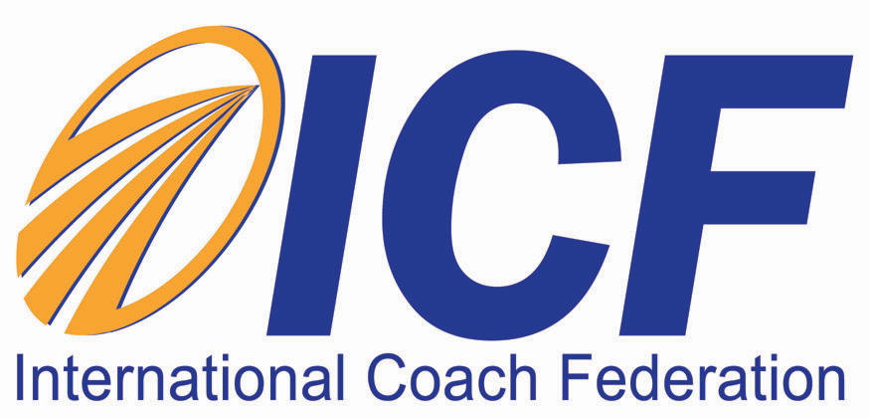

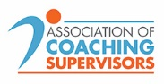

IPCC reports on climate change – https://www.ipcc.ch/reports/ https://www.ipcc.ch/2018/10/08/summary-for-policymakers-of-ipcc-special-report-on-global-warming-of-1-5c-approved-by-governments/ and https://www.ipcc.ch/sr15/chapter/spm/
IPCC reports on climate change - https://www.ipcc.ch/reports/ and https://www.ipcc.ch/2018/10/08/summary-for-policymakers-of-ipcc-special-report-on-global-warming-of-1-5c-approved-by-governments/
WHO (2018) Climate Change and Health: https://www.who.int/news-room/fact-sheets/detail/climate-change-and-health

